



ML Ops & Containerization
LAB MANUAL

Disclaimer: The content is curated from online/offline resources and used for educational purpose only
GitHub Branching – Online Quiz Application
Objective
To learn how to create branches, develop new features independently, merge changes, and manage project versions using GitHub.
Problem Statement
A development team is building an Online Quiz Application. Different developers work on separate features such as quiz questions and score calculation. Branches are used to avoid conflicts while developing independently.
Requirements
Software
- Git
- GitHub
- VS Code
Files
- README.md
- quiz.py
Procedure
Step 1: Clone Repository
git clone https://github.com/ramar92/OnlineQuiz.git
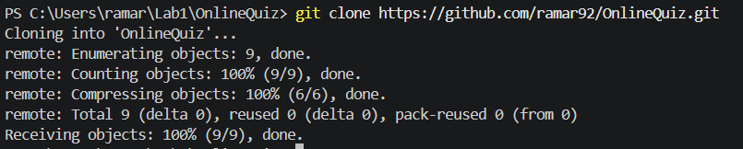

Step 2: Open Repository
cd OnlineQuiz
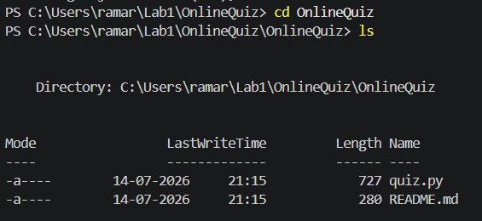

Step 3: View Branches
git branch

Step 4: Create Feature Branch
git checkout -b feature-score

Step 5: Modify quiz.py
Modified quiz.py file
score = 0

print("Welcome to Online Quiz")

answer = input("Python is used for Machine Learning? (yes/no): ")

if answer.lower() == "yes":
score = 10
print("Correct!")
else:
print("Wrong!")

print("Score:", score)

Step 6: Commit Changes
git add .
git commit -m " Updated the entire code for calculate the score"

Step 7: Push Feature Branch
git push origin feature-score
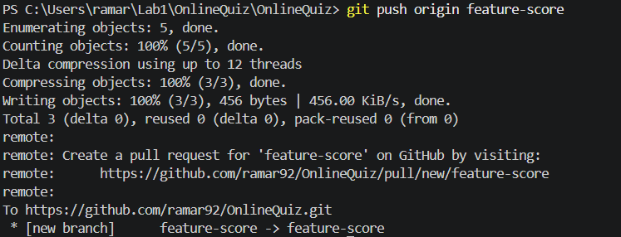

Step 8: Switch to Main Branch
git checkout main
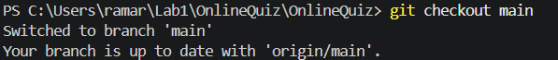

Step 9: Merge Branch
git merge feature-score
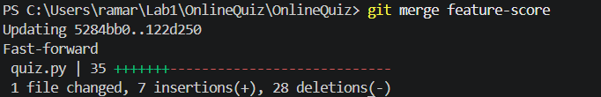

Step 10: Push Updated Main Branch
git push origin main
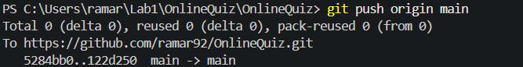
Conclusion
Students learned how Git branches enable independent feature development and safe integration into the main project.

